Administration Web Interface

Tiburon Administrative Website Pages
The following sections describe pages the user flows through to perform configuration and reporting functions by Tiburon staff. These features are shared by Electronic Lockers and ChargeDaddy except where explicitly noted.

Home Page
This is the page that appears when users navigate to the Tiburon administrative website whether they are logged in or not.
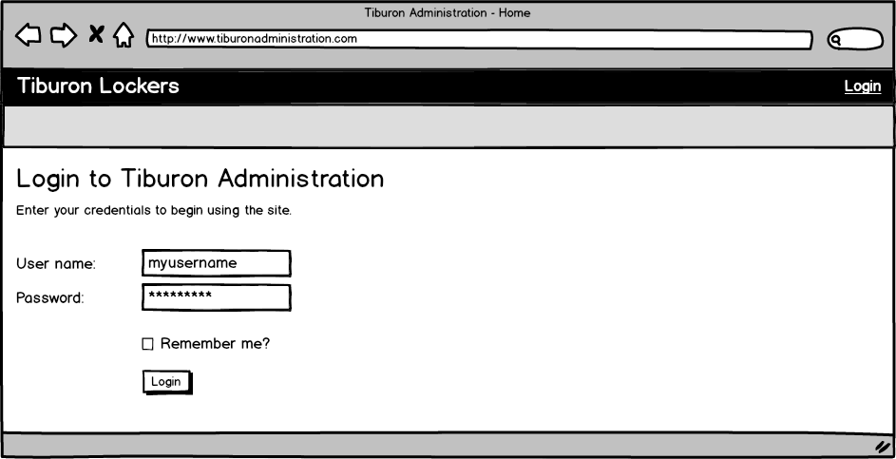
Figure 50: Home page

Event: | Tiburon Administration Home Page login
Description: | Allows users to login to admin website
Pre-Conditions: | The user must have appropriate administrative privileges.
Success Path: |  | The user browses to the Admin Login Page
 |  | The user enters their user name and password
 |  | The user clicks the login button
 |  | The system navigates to the Admin Home Page
Alternate Path: | User selects “Remember Me” option
 |  | The system will populate the username field on subsequent logins
Exception Path: | If the users credentials are invalid, the user will be prompted to re-enter their information.
Notes: | This interface may not be used to login “Venue” users.

List Venues Page
This page is displayed to list the venues that do business with Tiburon at which kiosks are deployed.
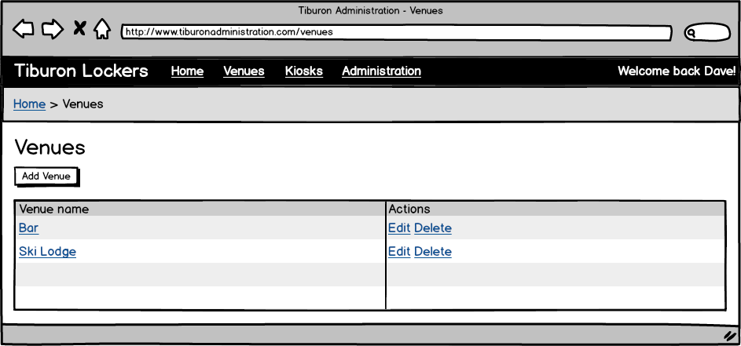
Figure 51: List Venues page
Event: | List Venue Page
Description: | Allows users manage venues
Pre-Conditions: | The user has logged in to the system via the Home Page
Success Path: |  | The user selects venues from the Admin navigation menu
 |  | The system displays the Venues List page (figure 49)

Event: | Navigating to the Add Venue page
Description: | Occurs when the Add Venue button is clicked
Success Path: |  | The user clicks the Add Venue button.
 |  | The system navigates to the Add/ Edit Venue page.
Event: | Navigating to the Edit Venue page
Description: | Occurs when the Edit link is clicked
Success Path: |  | The user clicks the Edit link for a selected venue.
 |  | The system navigates to the Add/ Edit Venue page.
Event: | Delete Venue
Description: | Occurs when the Delete link is clicked
Success Path: |  | The user clicks the Delete link for the selected venue.
 |  | The system will prompt the user to confirm the deletion.
 |  | If the user clicks yes, the record will be deleted from the database
 |  | If the user clicks no, the prompt closes and no record will be deleted from the database
Event: | Delete Venue
Description: | Occurs when the Delete link is clicked
Success Path: |  | The user clicks the Delete link for a selected venue.
 |  | The system will prompt the user to confirm the deletion.
 |  | If the user clicks yes, the record will be deleted from the database
 |  | If the user clicks no, the prompt closes and no record will be deleted from the database

Add/Edit Venue Page
This page is displayed to create or edit a venue that does business with Tiburon at which kiosks are deployed.
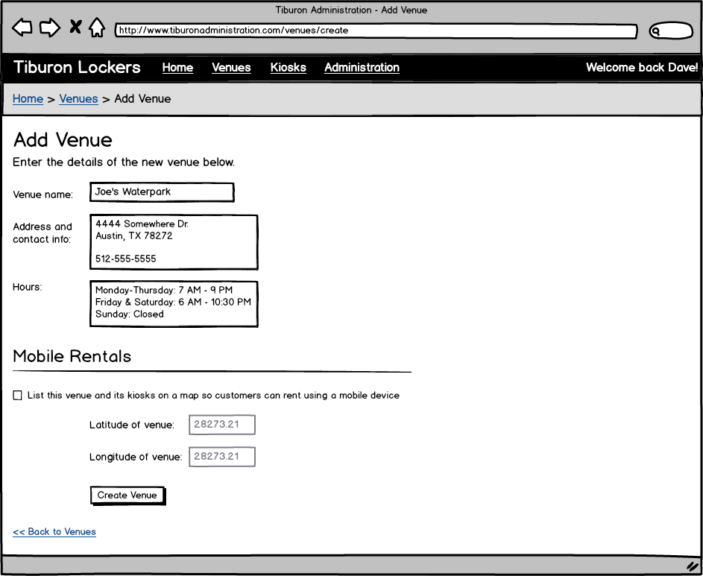
Figure 52: Add/Edit Venue page

Event: | Add/ Edit Venue Page
Description: | Allows users add or edit venues
Pre-Conditions: | The user has logged in to the system via the Home Page and selects Add Venue from List Venues page
Success Path: |  | The user has selected Add Venue from List Venues page
 |  | The system displays the Venues Details page (figure 50)
 |  | The user enters Venue data
 |  | The user clicks “Create Venue” button
 |  | The system performs field level validation and saves the record to the database
Alternate Path: | User has clicked “edit” option for existing venue
 |  | The system will populate the venue fields with existing data
 |  | The user modifies venue data
 |  | The user clicks the ‘Save’ button
 |  | The system performs field level validation and updates the record to the database.
Exception Path: | If the users entered data fails the field level validation, the user will be notified and no updates/ saves will be performed. The name is required but the address and hours are not.

Show Venue Page
This page is displayed to show the details of a venue that does business with Tiburon at which kiosks are deployed.
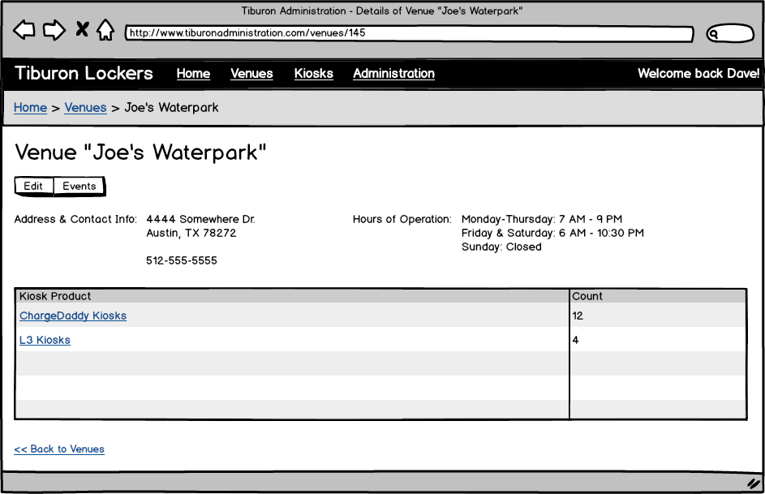
Figure 53: Show Venue page

Event: | Show Venue Page
Description: | Allows users view venues and related kiosk data
Pre-Conditions: | The user has logged in to the system via the Home Page and selects a venue from List Venues page by selecting the venue name
Success Path: |  | The user selects a venue
 |  | The system displays the Show Venue page (figure 51)

Event: | Navigating to the Edit Venue page
Description: | Occurs when the Edit button is clicked
Success Path: |  | The user clicks the Edit button for a selected venue.
 |  | The system navigates to the Add/ Edit Venue page.

Event: | Navigating to the Events page
Description: | Occurs when the Events button is clicked
Success Path: |  | The user clicks the Events button for a selected venue.
 |  | The system navigates to the Events page.

Event: | Navigating to the List Kiosks page
Description: | Occurs when the Kiosk link is clicked
Success Path: |  | The user clicks a Kiosk link for a selected venue.
 |  | The system navigates to the List Kiosks page.

List Kiosks Page
This page is displayed to list the kiosks deployed at a venue that does business with Tiburon.
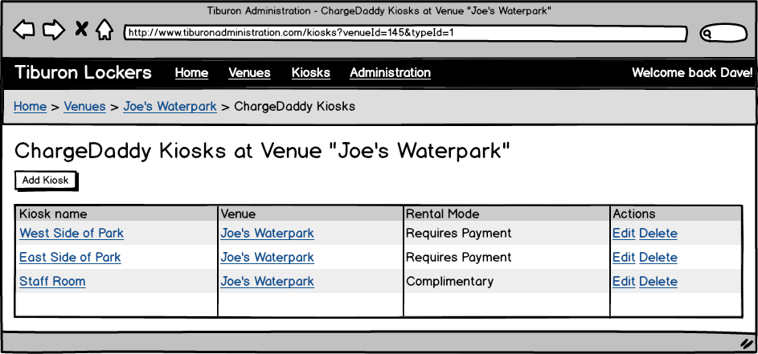
Figure 54: List Kiosks page

Event: | List Kiosks Page
Description: | Allows users view kiosks located at the venue.
Pre-Conditions: | The user has logged in to the system via the Home Page and navigated to the Show Venue page
Success Path: |  | The user selects a Kiosk Product from the Kiosk List table on the Show Venue page
 |  | The system displays the List Kiosk page (figure 52)

Event: | Navigating to the Show Kiosk page
Description: | Occurs when the Kiosk name link is clicked
Success Path: |  | The user clicks a Kiosk name link.
 |  | The system navigates to the Show Kiosk page.

Event: | Navigating to the Edit Kiosk page
Description: | Occurs when the Edit link is clicked for the kiosk
Success Path: |  | The user clicks a Kiosk link for a selected venue.
 |  | The system navigates to the Add/ Edit Kiosk page.

Event: | Navigating to the Edit Venue page
Description: | Occurs when the Venue link is clicked
Success Path: |  | The user clicks a Venue link for a selected venue.
 |  | The system navigates to the Add/ Edit Venue page.

Add/Edit Kiosk Page
This page is displayed to create or edit a kiosk deployed at a venue that does business with Tiburon.
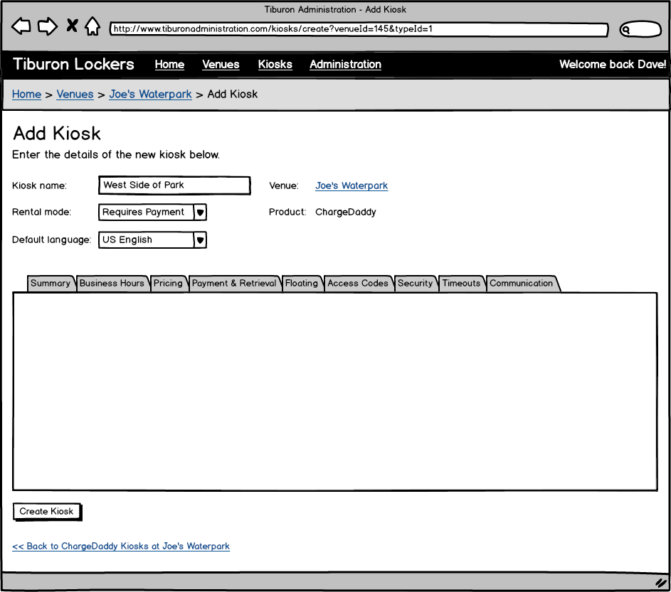
Figure 55: Add/Edit Kiosk page
Event: | Add/ Edit Kiosk Page
Description: | Allows users add or edit kiosks
Pre-Conditions: | The user has logged in to the system via the Home Page
Success Path: |  | The has selected “Add Kiosk” from List Kiosk page
 |  | The system displays the Add/ Edit Kiosk page (figure 53)
 |  | The user enters kiosk data
 |  | The user clicks “Create Kiosk” button
 |  | The system performs field level validation and saves the record to the database, including any changes performed on the tab Use Cases (7.2.4.6.1 – 7.2.4.6.10).
Alternate Path: | User has clicked “edit” option for existing kiosk
 |  | The system will populate the kiosk fields with existing data
 |  | The user modifies kiosk data
 |  | The user clicks the ‘Save’ button
 |  | The system performs field level validation and updates the record to the database, including any changes performed on the tab Use Cases (7.2.4.6.1 – 7.2.4.6.10).
Exception Path: | If the users entered data fails the field level validation, the user will be notified and no updates/ saves will be performed.

Kiosk Summary Information Tab
This tab of the page displayed to create or edit a kiosk allows a Tiburon administrator to configure summary information.
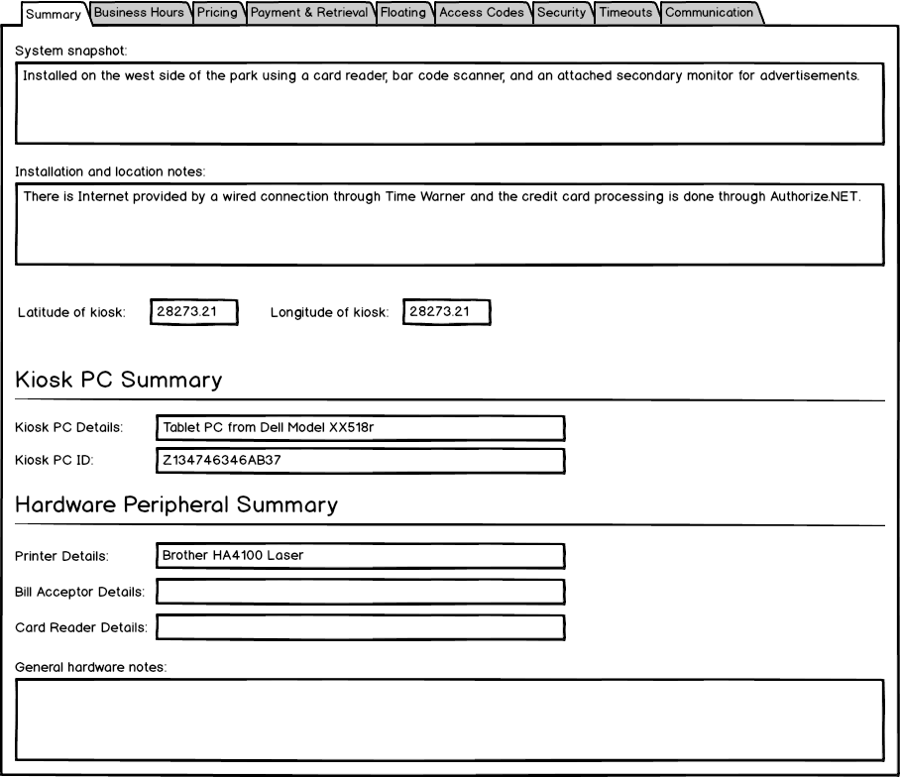
Figure 56: Kiosk Summary Information tab

Event: | Kiosk Summary Information Tab
Description: | Allows users add or edit kiosk summary information (PC details, installation notes etc.)
Pre-Conditions: | The user has logged in to the system via the Home Page and has selected Add Kiosk from List Kiosk page
Success Path: |  | The user selects the Summary tab
 |  | The system displays the Summary Information tab (figure 54)
 |  | The user enters Summary Information data
 |  | The user clicks “Create Kiosk” button on the Add/ Edit Kiosk page
 |  | The system performs field level validation and saves the record to the database
Alternate Path: | User has chosen to edit an existing kiosk and selected the Summary Information tab
 |  | The system will populate the Summary Information with existing data
 |  | The user modifies Summary Information data
 |  | The user clicks the ‘Save’ button on the Add/ Edit Kiosk page
 |  | The system performs field level validation and updates the record to the database
Exception Path: | If the users entered data fails the field level validation, the user will be notified and no updates/ saves will be performed.
Notes: | Field level validation details include field length, field required/ optional and datatype. Validation Details:  - Latitude and longitude optional; Decimal;  - Kiosk PC Details required; Alphanumeric; Length TBD  - Kiosk PC ID required; Alphanumeric; Length TBD  - Printer Details optional; Alphanumeric; Length TBD  - Bill Acceptor Details optional; Alphanumeric; Length TBD  - Card Reader Details required; Alphanumeric; Length TBD  - General Hardware Notes optional; Alphanumeric; Length TBD

Kiosk Business Hours Tab
This tab of the page displayed to create or edit a kiosk allows a Tiburon administrator to configure business hours at a kiosk.
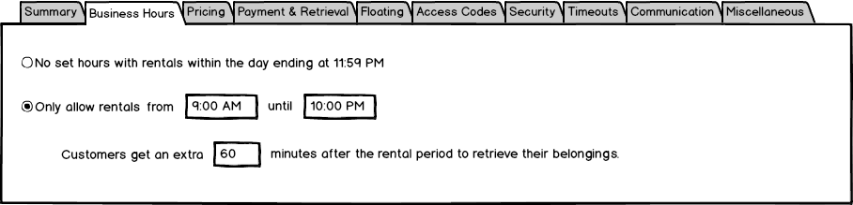
Figure 57: Kiosk Business Hours tab

Event: | Kiosk Business Hours Tab
Description: | Allows users add or edit kiosk business hours
Pre-Conditions: | The user has logged in to the system via the Home Page and has selected Add Kiosk from the List Kiosk page
Success Path: |  | The user selects the Business Hours tab
 |  | The system displays the Business Hours tab (figure 55)
 |  | The user enters Business Hours data
 |  | The user clicks “Create Kiosk” button on the Add/ Edit Kiosk page
 |  | The system performs field level validation and saves the record to the database
Alternate Path: | User has chosen to edit an existing kiosk and chooses the Business Hours tab
 |  | The system will populate the Business Hours with existing data
 |  | The user modifies Business Hours data
 |  | The user clicks the ‘Save’ button on the Add/ Edit Kiosk page
 |  | The system performs field level validation and updates the record to the database
Exception Path: | If the users entered data fails the field level validation, the user will be notified and no updates/ saves will be performed.
Notes: | Field level validation details include field length, field required/ optional and datatype. Validation Details:  - “No set hours…” option will be selected by default  - If “Only allow rentals…” option selected, “from” and “until” time dropdowns must have a selected value;  - The until time must be later than the from time  - If “Only allow rentals…” option selected, extra hours field required; Numeric; Length TBD

Kiosk Pricing Tab
This tab of the page displayed to create or edit a kiosk allows a Tiburon administrator to configure general settings.
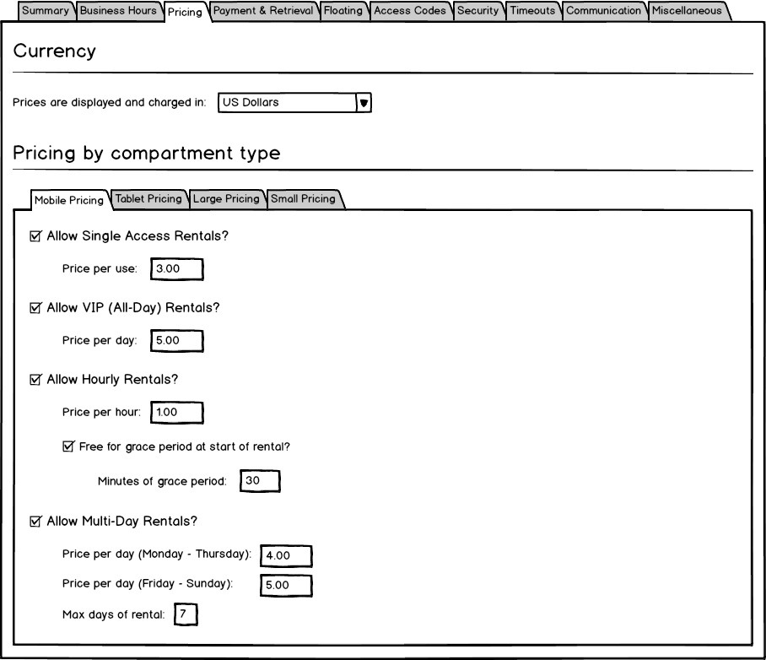
Figure 58: Kiosk Pricing tab

Event: | Kiosk Pricing Tab
Description: | Allows users add or edit kiosk pricing information
Pre-Conditions: | The user has logged in to the system via the Home Page and has selected Add Kiosk from the List Kiosk page
Success Path: |  | The user selects the Pricing tab
 |  | The system displays the Pricing tab (figure 56)
 |  | The user enters Pricing data
 |  | The user clicks “Create Kiosk” button on the Add/ Edit Kiosk page
 |  | The system performs field level validation and saves the record to the database
Alternate Path: | User has chosen to edit an existing kiosk and chooses the Pricing tab
 |  | The system will populate the Pricing tab with existing data
 |  | The user modifies Pricing data
 |  | The user clicks the ‘Save’ button on the Add/ Edit Kiosk page
 |  | The system performs field level validation and updates the record to the database
Exception Path: | If the users entered data fails the field level validation, the user will be notified and no updates/ saves will be performed.
Assumptions: | If no compartment types are configured, the kiosk can still be saved but pricing information will not be available until there are compartment types.
Notes: | Field level validation details include field length, field required/ optional and datatype. Validation Details:  - One checkbox must be selected (Allow single, Allow VIP, Allow hourly, Allow multi-day)  - If checkbox selected, it’s corresponding input field(s) is required; Numeric; Length TBD  - The currency is set to US Dollars by default.

Kiosk Payment & Retrieval Tab
This tab of the page displayed to create or edit a kiosk allows a Tiburon administrator to configure which types of credentials are valid for renting a compartment and later retrieving the contents of it.
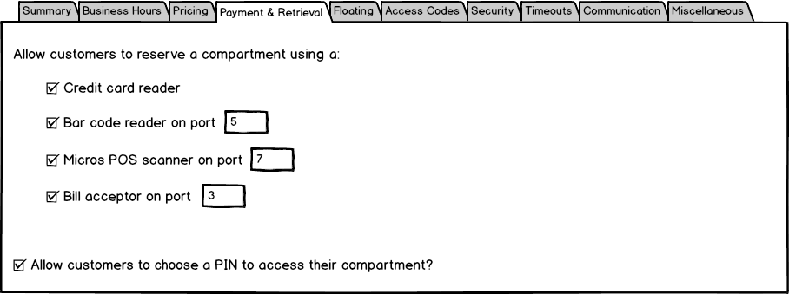
Figure 59: Kiosk Payment & Retrieval tab

Event: | Kiosk Payment & Retrieval Tab
Description: | Allows users add or edit kiosk payment and retrieval data
Pre-Conditions: | The user has logged in to the system via the Home Page and has selected Add Kiosk from the List Kiosk page
Success Path: |  | The user selects the Payment & Retrieval tab
 |  | The system displays the Payment & Retrieval tab (figure 57)
 |  | The user enters Payment & Retrieval data
 |  | The user clicks “Create Kiosk” button on the Add/ Edit Kiosk page
 |  | The system performs field level validation and saves the record to the database
Alternate Path: | User has chosen to edit an existing kiosk and chooses the Payment & Retrieval tab
 |  | The system will populate the Payment & Retrieval tab with existing data
 |  | The user modifies Payment & Retrieval data
 |  | The user clicks the ‘Save’ button on the Add/ Edit Kiosk page
 |  | The system performs field level validation and updates the record to the database
Exception Path: | If the users entered data fails the field level validation, the user will be notified and no updates/ saves will be performed.
Notes: | Field level validation details include field length, field required/ optional and datatype. Validation Details:  - At least one checkbox must be selected under the “Allow customers to reserve a compartment using a” section  - If checkbox selected, it’s corresponding input field is required; Numeric; Length TBD

Kiosk Floating Settings Tab
This tab of the page displayed to create or edit a kiosk allows a Tiburon administrator to configure the settings used when floating a rental.
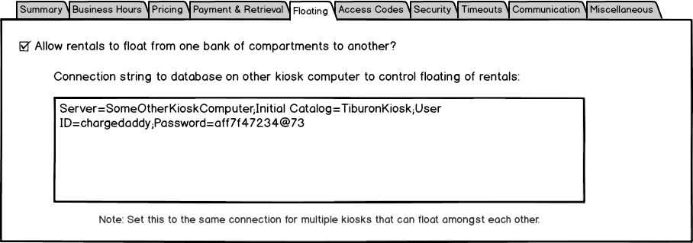
Figure 60: Kiosk Floating Settings tab

Event: | Kiosk Floating Settings Tab
Description: | Allows users add or edit kiosk floating settings
Pre-Conditions: | The user has logged in to the system via the Home Page and has selected Add Kiosk from the List Kiosk page
Success Path: |  | The user selects the Floating tab
 |  | The system displays the Floating tab (figure 58)
 |  | The user enters Floating settings data
 |  | The user clicks “Create Kiosk” button on the Add/ Edit Kiosk page
 |  | The system performs field level validation and saves the record to the database
Alternate Path: | User has chosen to edit an existing kiosk and chooses the Business Hours tab
 |  | The system will populate the Floating tab with existing data
 |  | The user modifies Floating settings data
 |  | The user clicks the ‘Save’ button on the Add/ Edit Kiosk page
 |  | The system performs field level validation and updates the record to the database
Exception Path: | If the users entered data fails the field level validation, the user will be notified and no updates/ saves will be performed.
Notes: | Field level validation details include field length, field required/ optional and datatype. Validation Details:  - If “Allow rentals to float…" checkbox is checked, the connection string input will be required; Alphanumeric; Length TBD

Kiosk Access Codes Tab
This page is displayed to list and import access codes that are permitted to use for renting at a kiosk.
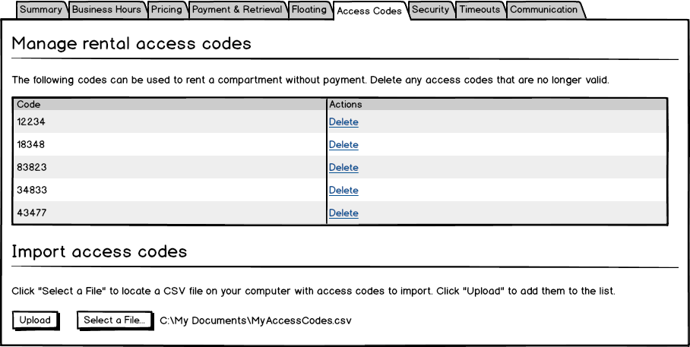
Figure 61: Kiosk Access Codes tab

Event: | Kiosk Access Codes Tab
Description: | Allows users manage rental access codes
Pre-Conditions: | The user has logged in to the system via the Home Page and has selected Add Kiosk from the List Kiosk page
Success Path: |  | The user selects the Access Codes tab
 |  | The system displays the Access Codes tab (figure 59)

Event: | Kiosk Access Codes Upload
Description: | Allows users add access codes
Pre-Conditions: | The user has logged in to the system via the Home Page and has selected Add Kiosk from the List Kiosk page
Success Path: |  | The user selects the Access Codes tab
 |  | The system displays the Access Codes tab (figure 59)
 |  | The system will show any existing codes in the display table
 |  | The user clicks “Select a File…” button
 |  | The user selects a .csv file that contains access codes
 |  | The user clicks “Upload” button
 |  | The user clicks “Create Kiosk” button on the Add/ Edit Kiosk page
 |  | The system reads the csv file and imports the data to the database
Exception Path: | If the csv upload fails, the user will be notified and prompted to re-try.

Event: | Kiosk Access Codes Delete
Description: | Allows users delete kiosk access codes
Pre-Conditions: | The user has logged in to the system via the Home Page and has selected Add Kiosk from the List Kiosk page
Success Path: |  | The user selects the Access Codes tab
 |  | The system displays the Access Codes tab (figure 59)
 |  | The system will show any existing codes in the display table
 |  | The user clicks the “Delete” link for a specific Access Code
 |  | The system displays a message asking for delete confirmation (Yes/ No)
 |  | If the user clicks yes, the record will be deleted from the database
 |  | If the user clicks no, the prompt closes and no record will be deleted from the database
Exception Path: | If the csv upload fails, the user will be notified and prompted to re-try.
Assumptions: | If there are existing access codes with the same value as what’s being imported via CSV they are skipped and all unique access codes are still imported.

Kiosk Security Tab
This page is displayed to allow configuration of security settings on the kiosk.
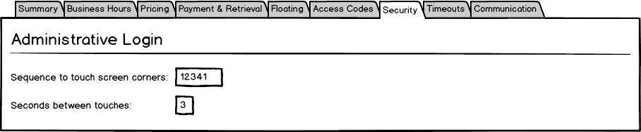
Figure 62: Kiosk Security tab

Event: | Kiosk Security Tab
Description: | Allows users add or edit kiosk security information
Pre-Conditions: | The user has logged in to the system via the Home Page and has selected Add Kiosk from the List Kiosk page
Success Path: |  | The user selects the Security tab
 |  | The system displays the Security tab (figure 60)
 |  | The user enters Security data
 |  | The user clicks “Create Kiosk” button on the Add/ Edit Kiosk page
 |  | The system performs field level validation and saves the record to the database
Alternate Path: | User has chosen to edit an existing kiosk and chooses the Security tab
 |  | The system will populate the Security tab with existing data
 |  | The user modifies Security data
 |  | The user clicks the ‘Save’ button on the Add/ Edit Kiosk page
 |  | The system performs field level validation and updates the record to the database
Exception Path: | If the users entered data fails the field level validation, the user will be notified and no updates/ saves will be performed.
Notes: | Field level validation details include field length, field required/ optional and datatype. Validation Details:  - “Sequence to touch…” input required; Numeric; Values limited to 1-4; Length TBD  - “Seconds between touch…” required; Numeric; Positive; Length TBD

Kiosk Timeouts Tab
This tab of the page displayed to create or edit a kiosk allows a Tiburon administrator to configure the duration of timeouts that occur across a variety of time-sensitive operations when using the kiosk application.
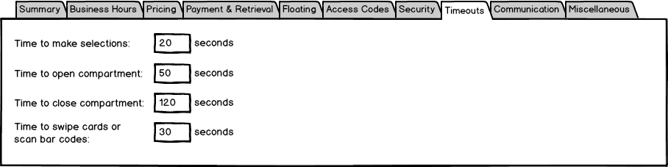
Figure 63: Kiosk Timeouts tab

Event: | Kiosk Timeouts Tab
Description: | Allows users add or edit kiosk timeouts
Pre-Conditions: | The user has logged in to the system via the Home Page and has selected Add Kiosk from the List Kiosk page
Success Path: |  | The user selects the Timeouts tab
 |  | The system displays the Timeouts tab (figure 61)
 |  | The user enters Timeout data
 |  | The user clicks “Create Kiosk” button on the Add/ Edit Kiosk page
 |  | The system performs field level validation and saves the record to the database
Alternate Path: | User has chosen to edit an existing kiosk and chooses the Timeouts tab
 |  | The system will populate the Timeouts tab with existing data
 |  | The user modifies Timeouts data
 |  | The user clicks the ‘Save’ button on the Add/ Edit Kiosk page
 |  | The system performs field level validation and updates the record to the database
Exception Path: | If the users entered data fails the field level validation, the user will be notified and no updates/ saves will be performed.
Notes: | Field level validation details include field length, field required/ optional and datatype. Validation Details:  - “Time to make selections” required; Numeric; Length TBD  - “Time to open compartment” required; Numeric; Length TBD  - “Time to close compartment” required; Numeric; Length TBD  - “Time to swipe cards and scan bar codes” required; Numeric; Length TBD

Kiosk Communication Settings Tab
This tab of the page displayed to create or edit a kiosk allows a Tiburon administrator to configure hardware and notification settings used on the kiosk.
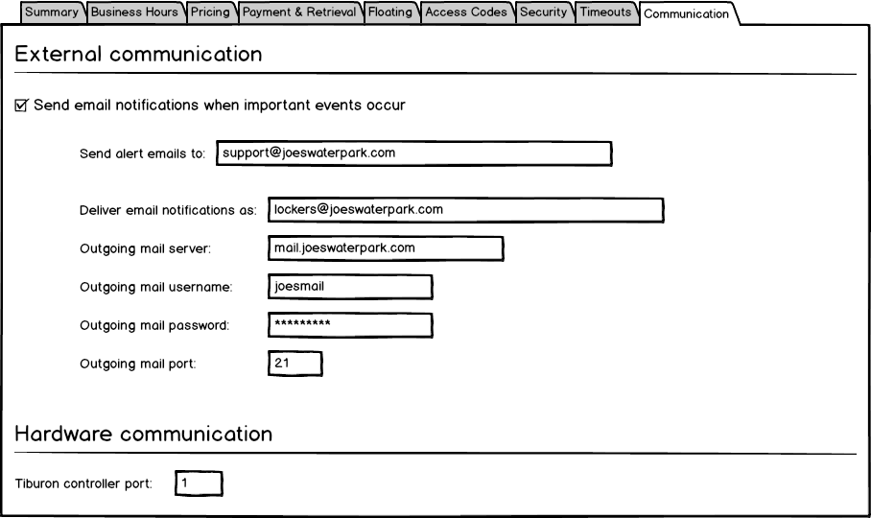
Figure 64: Kiosk Communication Settings tab

Event: | Kiosk Communication Settings Tab
Description: | Allows users add or edit kiosk business hours
Pre-Conditions: | The user has logged in to the system via the Home Page and has selected Add Kiosk from the List Kiosk page
Success Path: |  | The user selects the Communication Settings tab
 |  | The system displays the Communication Settings tab (figure 62)
 |  | The user enters Communication Settings data
 |  | The user clicks “Create Kiosk” button on the Add/ Edit Kiosk page
 |  | The “Send email notifications” checkbox is unchecked by default.
 |  | The system performs field level validation and saves the record to the database
Alternate Path: | User has chosen to edit an existing kiosk and chooses the Communication Settings tab
 |  | The system will populate the Communication Settings tab with existing data
 |  | The user modifies Communication Settings data
 |  | The user clicks the ‘Save’ button on the Add/ Edit Kiosk page
 |  | The system performs field level validation and updates the record to the database
Exception Path: | If the users entered data fails the field level validation, the user will be notified and no updates/ saves will be performed.
Notes: | Field level validation details include field length, field required/ optional and datatype. Validation Details:  - “Send email alerts to” required if “Send email notifications” is checked; Alphanumeric; Length TBD  - “Deliver email notifications as” required if “Send email notifications” is checked; Alphanumeric; Length TBD  - “Outgoing mail server” required if “Send email notifications” is checked; Alphanumeric; Length TBD  - “Outgoing mail username” required if “Send email notifications” is checked; Alphanumeric; Length TBD  - “Outgoing mail password” required if “Send email notifications” is checked; Alphanumeric; Length TBD  - “Outgoing mail port” required if “Send email notifications” is checked; Numeric; Length TBD  - “Tiburon controller port” required; Numeric; Length TBD

Show Kiosk Page
This page is displayed to show the details of a kiosk deployed at a venue that does business with Tiburon.
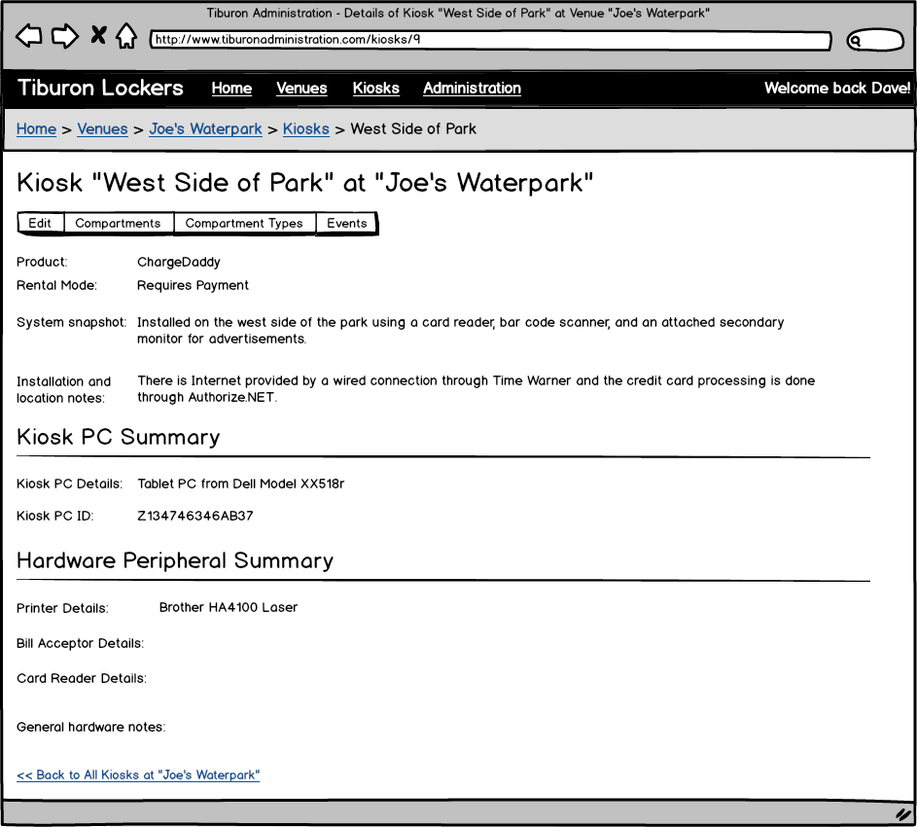
Figure 65: Show Kiosk page

Event: | Display show kiosk page
Description: | This displays a page with a summary of a kiosk.
Pre-Conditions: | - The Tiburon Administrator has added a kiosk using the Add/Edit Kiosk page.  - The user logged into the website must be a member of the Tiburon Administrators role, or have its Venue set to the same venue the kiosk belongs to for them to have permission to view this page.
Success Path: |  | The page title reads “Kiosk <KioskName> of <Venue Name>”
 |  | The compartments button is hidden if the user logged into the website is not a member of the Tiburon Administrators role.
 |  | The compartment types button is hidden if the user logged into the website is not a member of the Tiburon Administrators role.
 |  | The product label reads “ChargeDaddy” or “Electronic Lockers” depending on whether the kiosk is configured for one product or another.
 |  | The rental mode field reads “Requires Payment” or “Complimentary” to match what was set on the Add/Edit Kiosk page for the kiosk being displayed.
 |  | The remaining label values in the screen design contain the text to match what was entered on the Add/Edit Kiosk page for the kiosk being displayed.
 |  | The breadcrumb at the top of the page allows linking to the Landing page, all venues, the venue this kiosk belongs to, and all kiosks for the venue.
 |  | The back link reads “Back to All Kiosks for <Venue Name>”.

Event: | Initiate editing the kiosk
Description: | This navigates to a page used to edit the kiosk.
Success Path: |  | The user clicks the “Edit” button on the page.
 |  | The browser navigates to the Add/Edit Kiosk page for the currently displayed kiosk.

Event: | Initiate listing the compartments of the kiosk
Description: | This navigates to a page used to list the compartments of the kiosk.
Success Path: |  | The user clicks the “Compartments” button on the page.
 |  | The browser navigates to the List Compartments page for the currently displayed kiosk.

Event: | Initiate listing the compartment types of the kiosk
Description: | This navigates to a page used to list the compartment types of the kiosk.
Success Path: |  | The user clicks the “Compartment Types” button on the page.
 |  | The browser navigates to the List Compartment Types page for the currently displayed kiosk.

Event: | Initiate listing the events of the kiosk
Description: | This navigates to a page used to list the events of the kiosk.
Success Path: |  | The user clicks the “Events” button on the page.
 |  | The browser navigates to the Kiosk Events page filtered to display data for the currently displayed kiosk.

Event: | Navigate to all kiosks of the same type
Description: | This navigates to a page listing all kiosks of the same type (Electronic Lockers vs. ChargeDaddy) for the venue that this kiosk belongs to.
Success Path: |  | The user clicks the back link.
 |  | The browser navigates to the List Kiosks page to list all kiosks of the same type (Electronic Lockers vs. ChargeDaddy) for the venue that this kiosk belongs to.

Kiosk Events Page
This page is displayed to enable the user to list, sort, and filter events that occurred at a venue or kiosk.
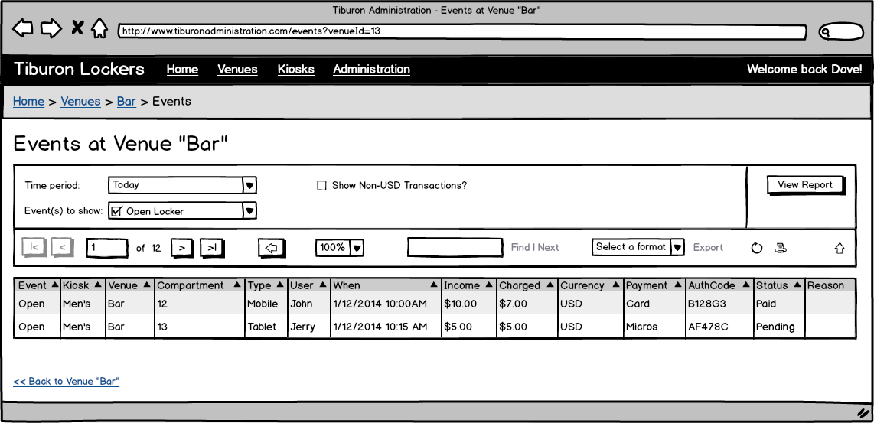
Figure 66: Kiosk Events page

Event: | Kiosk Events Page
Description: | Allows users to view events that occur at a venue or kiosk
Pre-Conditions: | The user has logged in to the system via the Home Page and has clicked on Events on the Show Venue page
Success Path: |  | On initial load, the system displays the parameter selection area
 |  | The user selects desired parameters/ filters and clicks the “View Report” button to run the report.
 |  | The system displays event data (figure 64)
 |  | The user may choose various built in options; navigation for multi-page reports, zoom-in/ zoom-out, find on page, export to another format (e.g. Excel) or print.

List Compartment Types Page
This page is displayed to list the types of compartments available at a kiosk of a venue.
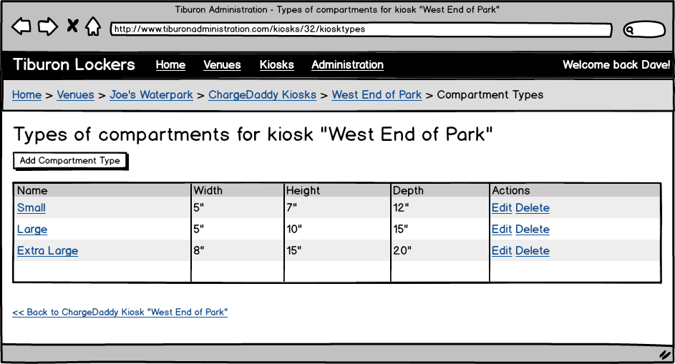
Figure 67: List Compartment Types page

Event: | List Compartments Type Page
Description: | Allows users view and manage compartment types for a specific kiosk
Pre-Conditions: | The user has logged in to the system via the Home Page
Success Path: |  | The user chooses a Kiosk Location from the List Kiosk page
 |  | The system displays the Compartment Types page (figure 65)

Event: | Navigating to the Add/Edit Compartment Type page
Description: | Occurs when the Add Compartment button is clicked
Success Path: |  | The user clicks a Add Compartment Type button.
 |  | The system navigates to the Add Compartment Type page.

Event: | Navigating to the Show Compartment Type page
Description: | Occurs when the Compartment Type name link is clicked in the compartment type grid
Success Path: |  | The user clicks a Compartment Type name link for a selected kiosk.
 |  | The system navigates to the Show Compartment Type page.

Event: | Navigating to the Edit Compartment Type page
Description: | Occurs when the Edit link is clicked
Success Path: |  | The user clicks the Edit link for a compartment type.
 |  | The system navigates to the Add/ Edit Venue page.
Event: | Delete Compartment Type
Description: | Occurs when the Delete link is clicked
Success Path: |  | The user clicks the Delete link for a selected compartment type.
 |  | The system will prompt the user to confirm the deletion.
 |  | If the user clicks yes, the record will be deleted from the database
 |  | If the user clicks no, the prompt closes and no record will be deleted from the database

Add/Edit Compartment Type Page
This page is displayed to create or edit a type of compartment available at a kiosk of a venue.
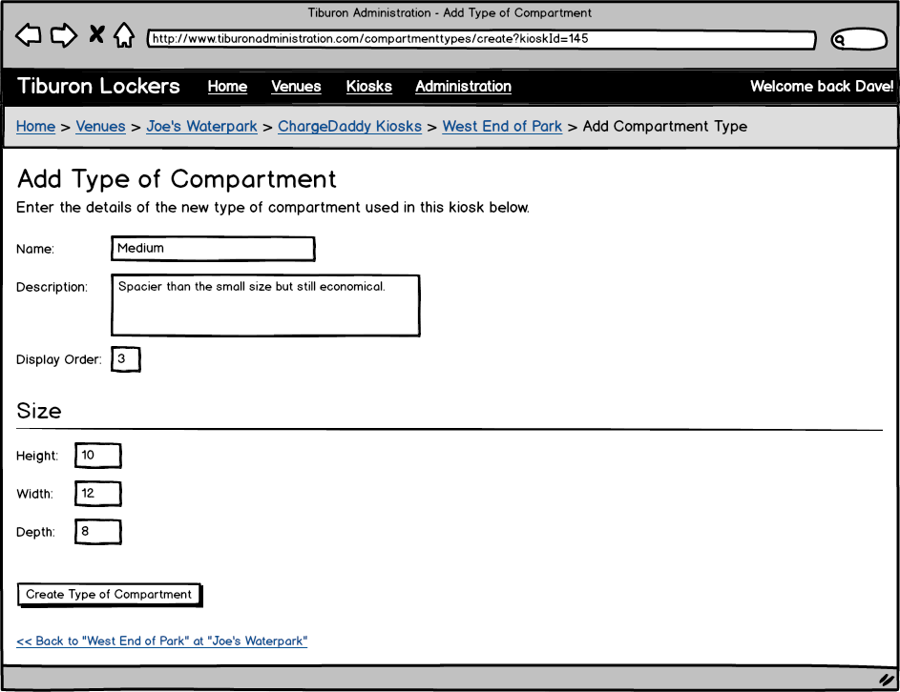
Figure 68: Add/Edit Compartment Type page

Event: | Add/ Edit Compartments Type Page
Description: | Allows users add or edit compartment types for a selected kiosk
Pre-Conditions: | The user has logged in to the system via the Home Page
Success Path: |  | The user clicks the Add Compartment Type button from the List Compartment Types page
 |  | The system displays the Add/ Edit Compartment Type page (figure 66)
 |  | The user enters Compartment Type data
 |  | The user clicks “Create Type of Compartment” button
 |  | The system performs field level validation and saves the record to the database
Alternate Path: | User clicks “edit” option for existing compartment type on the List Compartment Types page
 |  | The system will populate the compartment type fields with existing data
 |  | The user modifies compartment type data
 |  | The user clicks the ‘Save’ button
 |  | The system performs field level validation and updates the record to the database
Alternate Path: | User clicks “delete” option for existing compartment type on the List Compartment Types page
 |  | The system will prompt the user to confirm the deletion
 |  | If the user clicks yes, the record will be deleted from the database
 |  | If the user clicks no, the prompt closes and no record will be deleted from the database
Exception Path: | If the users entered data fails the field level validation, the user will be notified and no updates/ saves will be performed.
Notes: | Field level validation details include field length, field required/ optional and datatype.  - Name, description, and display order are required  - Display order must be a positive number unique amongst other compartment types for the same kiosk

Show Compartment Type Page
This page is displayed to show the details of a compartment available at a kiosk of a venue.
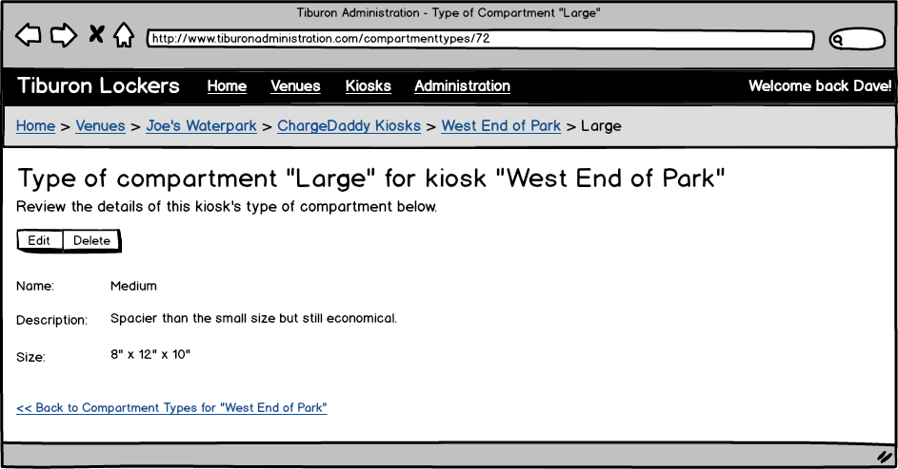
Figure 69: Show Compartment Type page

Event: | Show Compartments Type Page
Description: | Allows users view and manage compartment type
Pre-Conditions: | The user has logged in to the system via the Home Page
Success Path: |  | The user chooses a Compartment Type (e.g. Small, Medium, Large) from the List Compartment Types page
 |  | The system displays the Show Compartment Types page (figure 67)

List Compartments Page
This page is displayed to list the compartments configured for a kiosk of a venue.
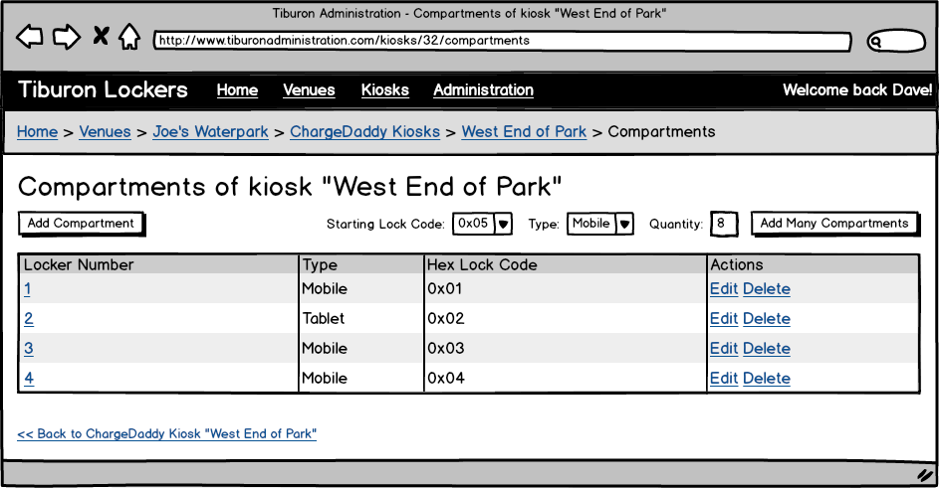
Figure 70: List Compartments page

Event: | List Compartments Page
Description: | Allows users view and manage compartment types for a specific kiosk
Pre-Conditions: | The user has logged in to the system via the Home Page
Success Path: |  | The user chooses a Kiosk Location from the List Kiosk page and selects “Compartments”
 |  | The system displays the Compartment page (figure 68)

Event: | Adding Multiple Compartments
Description: | Allows users to add multiple compartments in one step
Pre-Conditions: | The user has logged in to the system via the Home Page
Success Path: |  | The user selects the starting lock number, type, and enters a positive number greater than zero for the quantity.
 |  | The system adds a compartment with incrementing lock numbers set to the type selected. If there are any overlapping existing lock numbers, these are skipped.
Notes: | Validate that the quantity is not greater than the 255 minus the number of compartments that are already configured for the kiosk.

Add/Edit Compartment Page
This page is displayed to create or edit a compartment available at a kiosk of a venue.
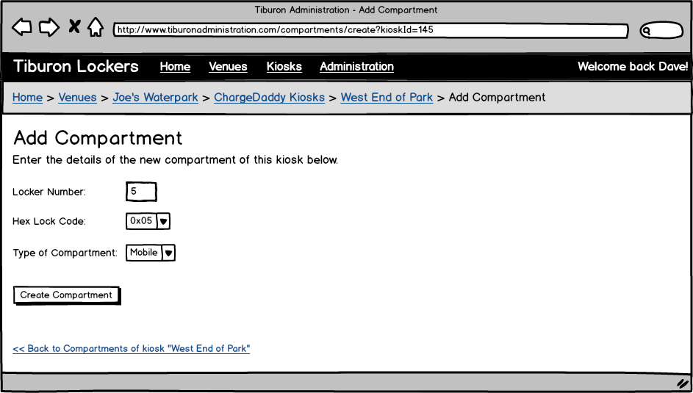
Figure 71: Add/Edit Compartment page

Event: | Add/ Edit Compartments Page
Description: | Allows users add or edit compartment types for a selected kiosk
Pre-Conditions: | The user has logged in to the system via the Home Page
Success Path: |  | The user clicks the Add Compartment Type button from the List Compartment page
 |  | The system displays the Add/ Edit Compartment page (figure 69)
 |  | The user enters Compartment data
 |  | The user clicks “Create Compartment” button
 |  | The system performs field level validation and saves the record to the database
Alternate Path: | User clicks “edit” option for existing compartment on the List Compartment page
 |  | The system will populate the compartment fields with existing data
 |  | The user modifies compartment data
 |  | The user clicks the ‘Save’ button
 |  | The system performs field level validation and updates the record to the database
Alternate Path: | User clicks “delete” option for existing compartment type on the List Compartment page
 |  | The system will prompt the user to confirm the deletion
 |  | If the user clicks yes, the record will be deleted from the database
 |  | If the user clicks no, the prompt closes and no record will be deleted from the database
Exception Path: | If the users entered data fails the field level validation, the user will be notified and no updates/ saves will be performed.
Notes: | Validate that the quantity is not greater than the 255 minus the number of compartments that are already configured for the kiosk.  Field level validation details include field length, field required/ optional and datatype. Validation Details:  - “Locker Number” required; Alphanumeric; Length TBD  - “Hex Lock Code” required (must make selection from list)  - “Type of Compartment” required (must make selection from list)

Show Compartment Page
This page is displayed to show the details of a compartment available at a kiosk of a venue.
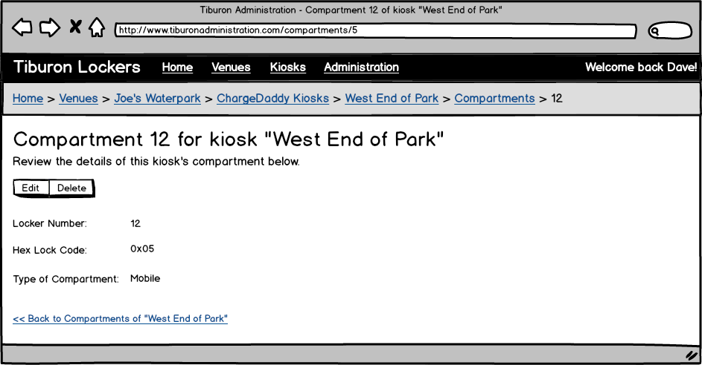
Figure 72: Show Compartment page

Event: | Show Compartments Page
Description: | Allows users view and manage compartments
Pre-Conditions: | The user has logged in to the system via the Home Page
Success Path: |  | The user chooses a Compartment (e.g. Small, Medium, Large) from the List Compartment page
 |  | The system displays the Show Compartment page (figure 70)

Administration Landing Page
This page is displayed to allow the user to navigate to the other pages of the Administrative website related to administering its security and general settings.

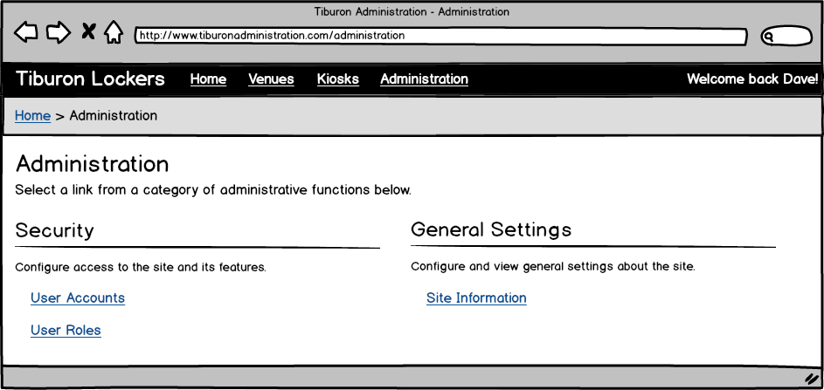
Figure 73: Administration Landing page

Event: | Display Administration Landing Page
Description: | Allows users navigate to various administrative pages
Pre-Conditions: | The user has logged in to the system via the Home Page
Success Path: |  | The user chooses a Administration link from the top navigation menu
 |  | The system displays the Administration Landing page (figure 72)

Event: | User Accounts link
Description: | Allows users to navigate to the User Account page
Pre-Conditions: | The user has logged in to the system via the Home Page
Success Path: |  | The user clicks the User Accounts link.
 |  | The system navigates to the List User Accounts page.

Event: | User Roles link
Description: | Allows users to navigate to the User Roles page
Pre-Conditions: | The user has logged in to the system via the Home Page
Success Path: |  | The user clicks the User Roles link.
 |  | The system navigates to the List User Roles page.

Event: | Site Information link
Description: | Allows users to navigate to the Site Information page
Pre-Conditions: | The user has logged in to the system via the Home Page
Success Path: |  | The user selects the Site Information link.
 |  | The system navigates to the Site Information page.

Site Information Page
This page is displayed to allow the user to see what version of the Administrative website they are working with and which environment it is deployed into.

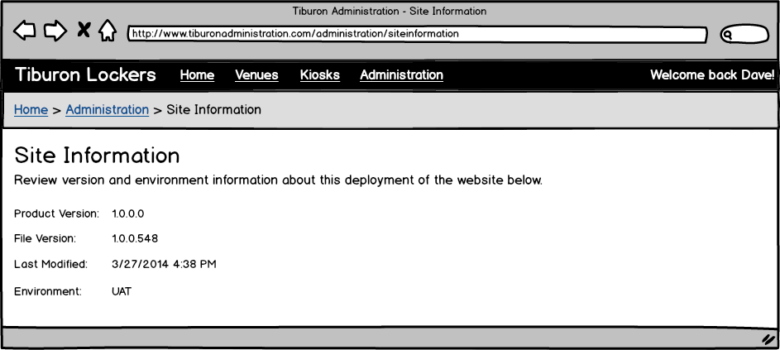
Figure 74: Site Information page

Event: | Site Information
Description: | Allows users view Site Information page
Pre-Conditions: | The user has logged in to the system via the Home Page
Success Path: |  | The user has selected selects the Site Information link from the Administration Landing page.
 |  | The system displays the Site Information page (figure 73).

List User Accounts Page
This page is displayed to list the user accounts permitted to login to the Administrative website.

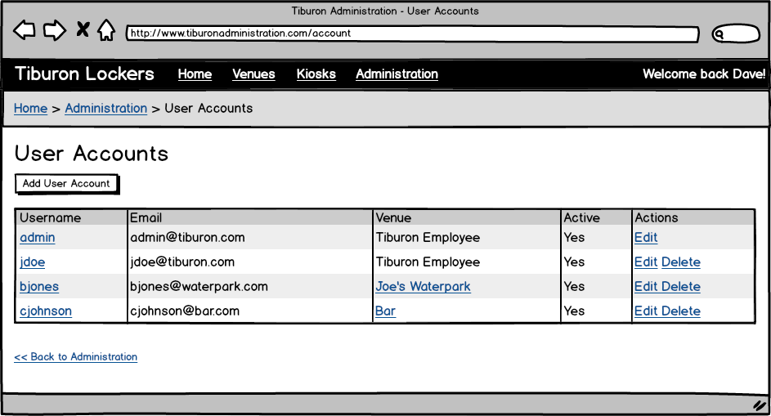
Figure 75: List User Accounts Page

Event: | List User Accounts Page
Description: | Allows administrators to view and manage users
Pre-Conditions: | The user has logged in to the system via the Home Page
Success Path: |  | The user chooses a User Accounts from the admin menu
 |  | The system displays the User Accounts list page (figure 74)
Event: | Add User Account Button
Description: | Allows users to navigate to the Add/Edit User Account page
Pre-Conditions: | The user has logged in to the system via the Home Page
Success Path: |  | The user clicks the Add User Account button.
 |  | The system navigates to the Add/Edit User Account page
Event: | User Account Username Link
Description: | Allows users to navigate to the Show User Account page
Pre-Conditions: | The user has logged in to the system via the Home Page
Success Path: |  | The user clicks the username link for a specific user.
 |  | The system navigates to the Show User Account page
Event: | User Account Venue Link
Description: | Allows users to navigate to the Show Venue page
Pre-Conditions: | The user has logged in to the system via the Home Page
Success Path: |  | The user clicks the link for a specific venue.
 |  | The system navigates to the Show Venue page

Event: | User Account Edit Action Link
Description: | Allows users to navigate to the Add/Edit User Account page
Pre-Conditions: | The user has logged in to the system via the Home Page
Success Path: |  | The user clicks the Edit link for a specific user.
 |  | The system navigates to the Add/Edit User Account page

Event: | User Account Delete Action Link
Description: | Allows administrators to delete a user
Pre-Conditions: | The user has logged in to the system via the Home Page
Success Path: |  | The user clicks the Delete link for a specific user.
 |  | The system will prompt the user to confirm the deletion
 |  | If the user clicks yes, the record will be deleted from the database
 |  | If the user clicks no, the prompt closes and no record will be deleted from the database
Notes: | The account with username “admin” cannot be deleted.

Add/Edit User Account Page
This page is displayed to create or edit a user account permitted to login to the Administrative website.

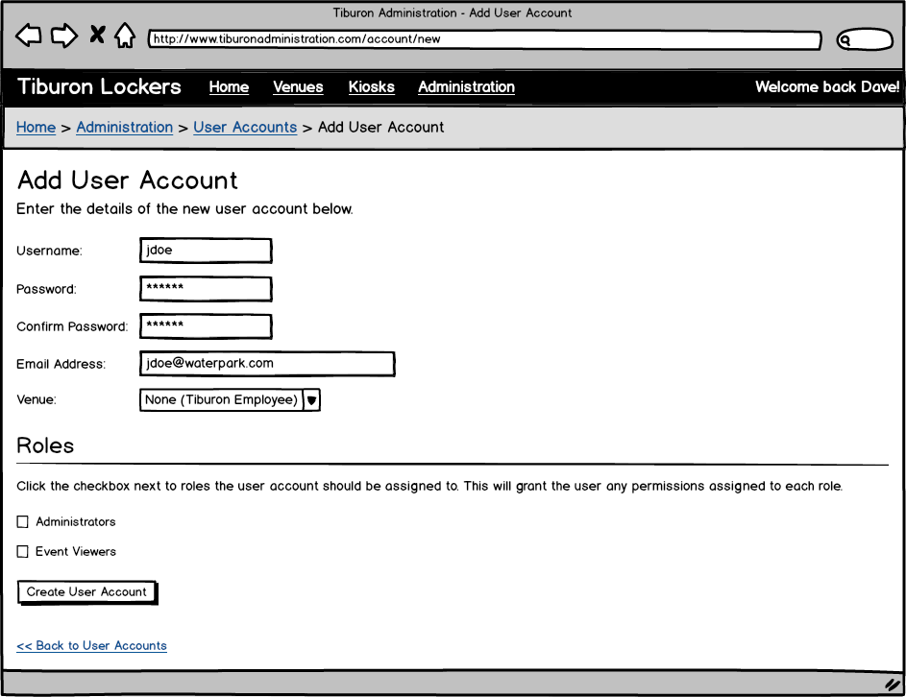
Figure 76: Add/Edit User Account Page

Event: | Add/ Edit User Accounts Page
Description: | Allows administrators to add or edit user accounts for the admin website
Pre-Conditions: | The user has logged in to the system via the Home Page
Success Path: |  | The user clicks the Add User button from the List User Account page
 |  | The system displays the Add/ Edit User Accounts page (figure 74)
 |  | The user enters User data
 |  | The user clicks “Create User Account” button
 |  | The system performs field level validation and saves the record to the database
Alternate Path: | Administrator clicks “edit” option for existing user on the List User Account page
 |  | The system will populate the user fields with existing data
 |  | The administrator modifies user data
 |  | The administrator clicks the ‘Save’ button
 |  | The system performs field level validation and updates the record to the database
Exception Path: | If the entered data fails the field level validation, the user will be notified and no updates/ saves will be performed.
Notes: | Field level validation details include field length, field required/ optional and datatype. Validation Details:  - “Username” required; Alphanumeric; Length TBD  - “Password/ Confirm Password” required; Alphanumeric; Length TBD  - “Email address” required; Alphanumeric; Length TBD  - “Venue” required (must make selection from list)  - If a venue is selected (other than “None”) no roles can be selected.

Show User Account Page
This page is displayed to show the details of a user account permitted to login to the Administrative website.

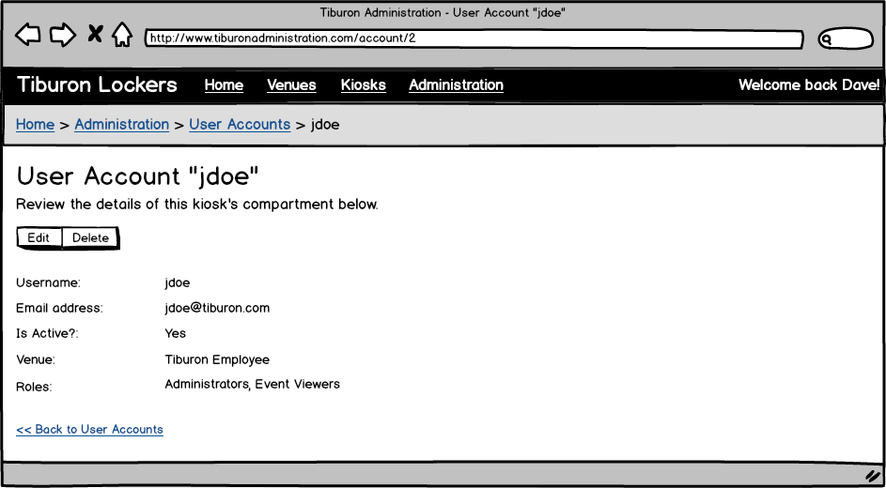
Figure 77: Show User Account Page

Event: | Show User Accounts Page
Description: | Allows users view and manage user accounts
Pre-Conditions: | The user has logged in to the system via the Home Page
Success Path: |  | The user chooses a user account from the List User Account page
 |  | The system displays the User Account page (figure 75)
Event: | User Account Edit Button
Description: | Allows users to navigate to the Add/Edit User Account page
Pre-Conditions: | The user has logged in to the system via the Home Page
Success Path: |  | The user clicks the Edit button
 |  | The system navigates to the Add/Edit User Account page
Event: | User Account Delete Button
Description: | Allows administrators to delete a user
Pre-Conditions: | The user has logged in to the system via the Home Page
Success Path: |  | The user clicks the Delete link for a specific user.
 |  | The system will prompt the user to confirm the deletion
 |  | If the user clicks yes, the record will be deleted from the database
 |  | If the user clicks no, the prompt closes and no record will be deleted from the database

List User Roles Page
This page is displayed to list the roles that can be assigned to user accounts permitted to login to the Administrative website.
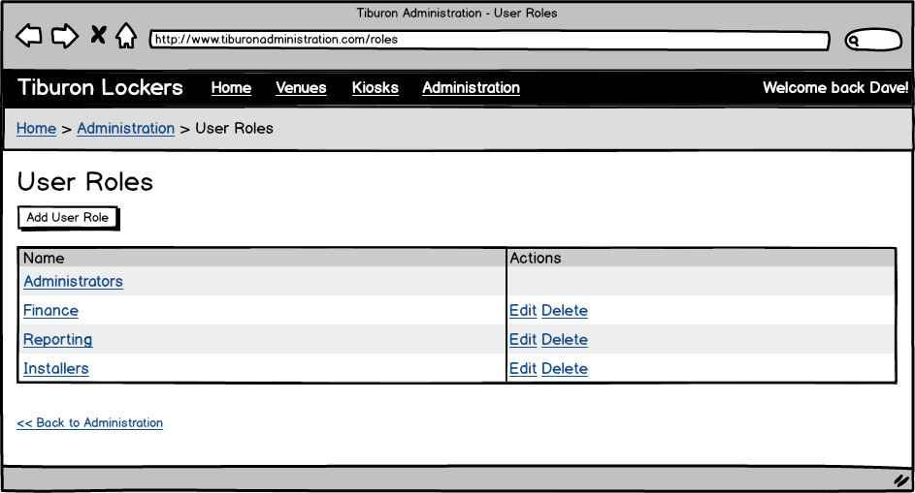
Figure 78: List User Roles page

Event: | List User Roles Page
Description: | Allows administrators to view and manage roles
Pre-Conditions: | The user has logged in to the system via the Home Page
Success Path: |  | The user chooses a User Roles from the admin menu
 |  | The system displays the User Roles list page (figure 76)
Event: | User Role Name Link
Description: | Allows users to navigate to the Show User Role page
Pre-Conditions: | The user has logged in to the system via the Home Page
Success Path: |  | The administrator clicks the user role name link for a specific role.
 |  | The system navigates to the Show User Role page
Event: | Add User Account Role
Description: | Allows users to navigate to the Add/Edit User Role page
Pre-Conditions: | The user has logged in to the system via the Home Page
Success Path: |  | The user clicks the Add User Role button.
 |  | The system navigates to the Add/Edit User Role page
Event: | User Role Edit Action Link
Description: | Allows users to navigate to the Add/Edit User Role page
Pre-Conditions: | The user has logged in to the system via the Home Page
Success Path: |  | The user clicks the Edit link for a specific user.
 |  | The system navigates to the Add/Edit User Role page

Event: | User Role Delete Action Link
Description: | Allows users to delete a user role
Pre-Conditions: | The user has logged in to the system via the Home Page
Success Path: |  | The user clicks the Delete link for a specific role.
 |  | The system will prompt the user to confirm the deletion
 |  | If the user clicks yes, the record will be deleted from the database
 |  | If the user clicks no, the prompt closes and no record will be deleted from the database
Exception Path: | Referential integrity: If the role is currently associated one or more user accounts, the user will be notified and no delete will occur.

Add/Edit User Role Page
This page is displayed to create or edit a role that can be assigned to a user account permitted to login to the Administrative website.

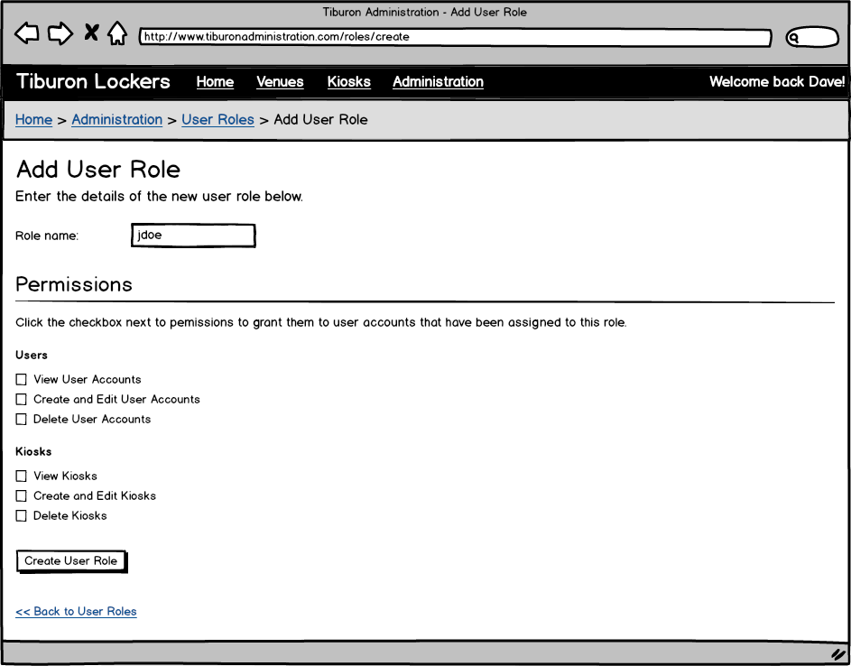
Figure 79: Add/Edit User Role page

Event: | Add/ Edit User Roles Page
Description: | Allows administrators to add or edit user roles for the admin website
Pre-Conditions: | The user has logged in to the system via the Home Page
Success Path: |  | The user clicks the Add User Role button from the List User Roles page
 |  | The system displays the Add/ Edit User Roles page (figure 78)
 |  | The user enters User Role data
 |  | The user clicks “Create User Role” button
 |  | The system performs field level validation and saves the record to the database
Alternate Path: | Administrator clicks “edit” option for existing user role on the List User Roles page
 |  | The system will populate the user role fields with existing data
 |  | The administrator modifies user role data
 |  | The administrator clicks the ‘Save’ button
 |  | The system performs field level validation and updates the record to the database
Exception Path: | If the entered data fails the field level validation, the user will be notified and no updates/ saves will be performed.
Notes: | Field level validation details include field length, field required/ optional and datatype. Validation Details:  - “Role name” required; Alphanumeric; Length TBD

Show User Role Page
This page is displayed to show the details of a role that can be assigned to a user account permitted to login to the Administrative website.

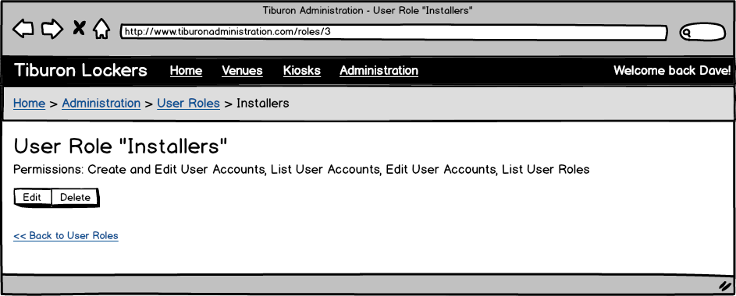
Figure 80: Show User Role page

Event: | Show User Role Page
Description: | Allows users view and manage user roles
Pre-Conditions: | The user has logged in to the system via the Home Page
Success Path: |  | The user chooses a user role from the List User Roles page
 |  | The system displays the User Roles page (figure 78)
Event: | User Role Edit Button
Description: | Allows users to navigate to the Add/Edit User Role page
Pre-Conditions: | The user has logged in to the system via the Home Page
Success Path: |  | The user clicks the Edit button
 |  | The system navigates to the Add/Edit User Role page

Event: | User Role Delete Button
Description: | Allows users to delete a user role
Pre-Conditions: | The user has logged in to the system via the Home Page
Success Path: |  | The user clicks the Delete link for a specific role.
 |  | The system will prompt the user to confirm the deletion
 |  | If the user clicks yes, the record will be deleted from the database
 |  | If the user clicks no, the prompt closes and no record will be deleted from the database
Exception Path: | Referential integrity: If the role is currently associated one or more user accounts, the user will be notified and no delete will occur.

Offline transaction reconciliation
This process reconciles transactions that were made when the kiosk was not connected to the Internet.

At night once following Nightly rental termination:
- Get a list of all transactions that
  - Have ended
  - Have not been successfully processed by the credit card processor
  - Have not failed for 3 credit processing attempts so far
- Submit each transaction to the credit card processor
  - Include exchange rate, amount, and transaction details
- For every successful transaction, update it in the database
- If a transaction fails, increment its failure count in the database
- Synchronize rentals with the Administrative Website

Nightly rental termination
This process terminates rentals that should conclude at the end of the day.

At a random time between 2 AM and 4 AM in the time zone of the kiosk computer:
- Update all Single Access rentals to ended.
- Update all VIP rentals to ended.
- Update all hourly rentals to ended.
  - Update price to reflect the compartment type, per-hour price, and number of hours excluding grace period
- Update all Multi-Day rentals that have hit the limit configured in the Kiosk Payment & Retrieval Tab to ended.
  - Update price to reflect the compartment type, per-day price, and number of days they were in the compartment.

Express station command receiver
This process polls a table for incoming hardware communication requests from an express station configured to allow retrieval of the contents of a rented locker or compartment from another kiosk.

- Use another kiosk’s database to determine rentals that exist
  - Hardware devices on the express station (card reader, bar code scanner etc.) trigger lookup of existing rental
- Update another kiosk’s database that a rental was ended
- Send an unlock compartment command to the other kiosk
- Request that another kiosk print a receipt
- Be notified that the compartment was opened on the other kiosk
- Be notified that the compartment was never opened (timed out) on the other kiosk
- Be notified that the compartment was closed on the other kiosk

Kiosk synchronization with Administrative website
Synchronizing Events – Kiosk to Website
The kiosk application (when running on the Tiburon hardware) will send any events (see the Kiosk Events Page for a complete list) to the Administrative Website.
Synchronizing – Website to Kiosk
Every night, once between 2:00 A.M. and 4:00 A.M. (in the Kiosk’s time zone), configuration changes made through the Administrative Website to that kiosk will automatically be synchronized. If configuration changes need to be synchronized immediately, this can be initiated by having a Venue or Tiburon Administrator click the “Force Sync” button on the General Settings page in the kiosk Administrative section of the application.

